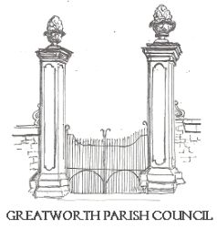 | GREATWORTH AND HALSE  PARISH COUNCIL | 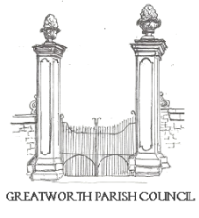
All Councillors are summoned to the Ordinary Meeting of Greatworth and Halse Parish Council to be held at the Methodist Church, Greatworth on Monday 2nd November 2026 at 7:30pm.

Members of the public and press are welcome to attend this meeting. This meeting may be recorded, filmed or broadcast without prior notice to the Parish Council, provided that such activity does not impede the conduct or business of the meeting.

AGENDA

- Apologies for absence
- Declarations of Interest
- Approval and signature of the minutes of the Annual General Meeting of 7th September 2026
- Open Time (15min max- 3min per person)
- Finance:
a) To receive the Finance Report and consider invoices to be paid
b) To review payments made by the Clerk, since the last meeting, under delegated powers of authority
c) To review cost of new bark needed for play area
d) To agree pay for community bus shelter cleaning
e) To discuss installing lights in alley ways off Pervil Way due to safety concerns
f) To discuss general and designated reserves ahead of 27/28 budget planning
- To receive the AGAR external audit report
- To discuss logistics for the first Community Engagement & Fundraising Committee.
- To review and update the council’s standing orders
- To review and update the Grants Policy
- To review discretionary grant application from GTCA
- To discuss new benches
- To discuss the potential for a Greatworth Neighbourhood Plan
- To review formal full council meeting schedule
- To review the current dog waste contract and discuss ongoing issues
- To review parish council response to the WNC Local Plan consultation (deadline 16th Nov)
- To receive an update on the future of the Glimpse newsletter and cost implications for the parish council
- To receive an update on the tree maintenance project
- To review current planning applications and approve any formal responses
- Councillor Questions
- Clerks Report and Action Tracker review
- Forward look: horizon scanning risk and opportunity and Glimpse additions
- Confidential: employee matters
- Date and location of the next meeting
- Close

Signed________________________ Dated______________

Shannon Smith, Clerk to Greatworth and Halse Parish Council
Or Chair of Greatworth and Halse Parish Council
01295 698336

