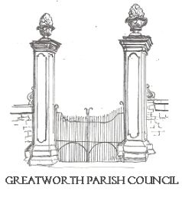 | GREATWORTH AND HALSE  PARISH COUNCIL | 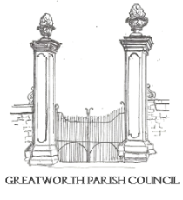
All Councillors are summoned to the Ordinary Meeting of Greatworth and Halse Parish Council to be held at the Mission Hall, Halse on Monday 7th September 2026 at 7:30pm.

Members of the public and press are welcome to attend this meeting. This meeting may be recorded, filmed or broadcast without prior notice to the Parish Council, provided that such activity does not impede the conduct or business of the meeting.

AGENDA

- Apologies for absence
- Receive the three new Councillor's Declaration of Acceptance of Office so they can legally take part in the meeting and become a member of the parish council
- Declarations of Interest
- Approval and signature of the minutes of the Ordinary Meeting of 6th July 2026 and the Emergency General Meeting of 13th August.
- Cllr Eastwood (WNC) to provide a brief update (10 minutes)
- Open Time (15min max- 3min per person)
- Finance:
a) To receive the Finance Report and consider invoices to be paid
b) To review payments made by the Clerk, since the last meeting, under delegated powers of authority
c) To approve the purchase of the village Christmas Tree in Halse
d) To discuss potential financial implications of changing the email system used by the council as existing system needs amending to facilitate newly coopted Cllrs and is not user friendly
- To review the annual small grants scheme applications and agree which to fund
- To discuss annual discretionary donations to local organisations
- To discuss establishing a new Community Engagement and Fundraising sub-committee
- To consider recent damage to the play park and to agree a budget for replacement bark, in line with the 2026 RoSPA inspection recommendation
- To consider West Northamptonshire Council’s exploration of a Parish Highways Representative Scheme and to discuss the Parish Council’s potential involvement, including the nomination of a councillor, staff member or community volunteer to act as the structured link between the community and WNC Highways, and a response to related NCALC poll.
- To review current planning applications and approve any formal responses
- Councillor Questions
- Clerks Report and Action Tracker review
- Forward look: horizon scanning risk and opportunity and Glimpse additions
- Date and location of the next meeting
- Close

Signed________________________ Dated______________

Shannon Smith, Clerk to Greatworth and Halse Parish Council
Or Chair of Greatworth and Halse Parish Council
01295 698336

