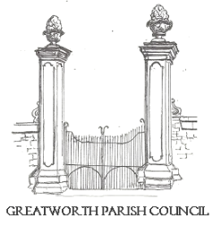 | GREATWORTH AND HALSE  PARISH COUNCIL | 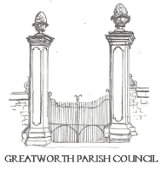
All Councillors are summoned to the Ordinary Meeting of Greatworth and Halse Parish Council to be held at the Methodist Church, Greatworth on Monday 5th January 2026 at 7:30pm.

Members of the public and press are welcome to attend this meeting. This meeting may be recorded, filmed or broadcast without prior notice to the Parish Council, provided that such activity does not impede the conduct or business of the meeting.

AGENDA

- Apologies for absence
- Declarations of Interest
- Approval and signature of the minutes of the Ordinary Meeting of 3rd November 2025
- Open Time (15min max- 3 min per person.)
- To consider any grant applications in relation to the allocation of the Community Solar Funding
- Finance:
- To receive the Finance Report and consider invoices to be paid
- To review payments made by the Clerk, since the last meeting, under delegated powers of authority

- To approve the Council’s 2026/27 budget
- To approve and sign the Council’s 2026/7 Precept Request paperwork.
- To discuss the relocation of the Defibrillator and approve any associated expenditure.
- To review current planning applications and approve any formal responses
- Councillor Questions
- Date and location of the next meeting
- Close

Signed________________________ Dated______________

Rebecca Foote, Clerk to Greatworth and Halse Parish Council
01295 698336

